Example No 01:

Input:

using System;

namespace Cp_Lab_10

{

class Program

{

static void AreaOfRectangle(int length , int breath)

{

int area = length * breath;

Console.WriteLine("Area of Rectangle = {0}", area);

}

static float AreaOfCircle(int r)

{

float pi = 3.14f;

float area1 = pi * r * r;

return area1;

}

static void DisplayTitle()

{

Console.WriteLine("\t\t-Function Lab-\n");

}

static void Main(string[] args)

{

int length, breath, r;

float AreaOfCir;

DisplayTitle();

Console.WriteLine("Enter Length");

length = int.Parse(Console.ReadLine());

Console.WriteLine("Enter Breath");

breath = int.Parse(Console.ReadLine());

Console.WriteLine("Enter Radius");

r = int.Parse(Console.ReadLine());

AreaOfRectangle(length, breath);

AreaOfCir = AreaOfCircle(r);

Console.WriteLine("Area of Circle = {0}", AreaOfCir);

}

}

}

Output:

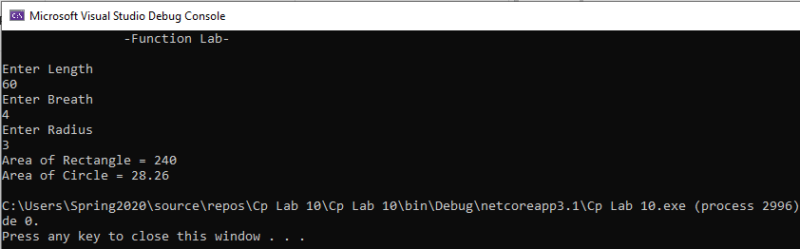

Task No 01: Write a method named square cube () that computes the square and cube of the value passed to it and display the result. Ask the user to provide the integer input in the main () and then call the function.

Input:

using System;

namespace CP_Lab_Tasks

{

class Program

{

static void square_cube(int n)

{

int sq = n * n;

int cube = n * n * n;

Console.WriteLine();

Console.WriteLine("Square of the number is " + sq);

Console.WriteLine("Cube of the number is " + cube);

}

static void Main(string[] args)

{

Console.WriteLine("Enter a number to print its square and cube: ");

int n = int.Parse(Console.ReadLine());

square_cube(n);

}

}

}

Output:

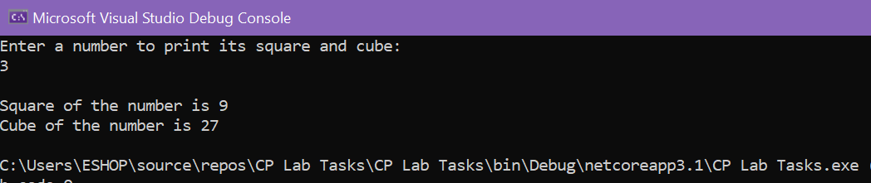

Task No 02: Write a method table () which generates multiplicative table of an integer. The function receives three integers as its arguments. The first argument determines the table to be generated while the second and the third integer tell the starting and ending point respectively. Ask the user to provide the three integers as input in the main ().

Input:

using System;

namespace CP_Lab_Tasks

{

class Program

{

static void tables(int x, int y, int z)

{

for (int i = y; i <= z; i++)

{

Console.WriteLine("\t{0} x {1} = {2}", x, i, x * i);

}

}

static void Main(string[] args)

{

int num, a, b;

Console.Write("Enter number for which you want the table :");

num = int.Parse(Console.ReadLine());

Console.Write("enter the starting point of the table :");

a = int.Parse(Console.ReadLine());

Console.Write("enter the ending point of the table:");

b = int.Parse(Console.ReadLine());

tables(num, a, b);

Console.ReadLine();

}

}

}

Output:

Task No 03: Create two function to find min and maximum value of any int array.

Input:

using System;

namespace CP_Lab_Tasks

{

class Program

{

static void Min(int[] arr)

{

int min = 0;

for (int i = 0; i < arr.Length; i++)

{

if (i == 0)

{

min = arr[i];

}

else if (min > arr[i])

{

min = arr[i];

}

}

Console.WriteLine("Minimum = {0}", min);

}

static void Max(int[] arr)

{

int max = 0;

for (int i = 0; i < arr.Length; i++)

{

if (i == 0)

{

max = arr[i];

}

else if (max < arr[i])

{

max = arr[i];

}

}

Console.WriteLine("Maximum = {0}", max);

}

static void Main(string[] args)

{

Console.Write("Enter the size of Array : ");

int size = int.Parse(Console.ReadLine());

int[] array = new int[size];

Console.WriteLine("Enter values of Array");

for (int i = 0; i < array.Length; i++)

{

Console.Write("Enter number {0} : ", i + 1);

array[i] = int.Parse(Console.ReadLine());

}

Min(array);

Max(array);

}

}

}

Output:

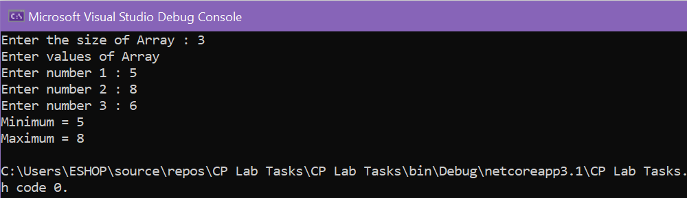

Task No 04: Take input of an array in on method and print reverse of that array.

Input:

using System;

namespace CP_Lab_Tasks

{

class Program

{

static void Main(string[] args)

{

Console.WriteLine("\t\t-: Reverse of Array :-\n");

Console.Write("Enter number of elements: ");

int n = int.Parse(Console.ReadLine());

int[] a = new int[n];

Console.Write("\nEnter elements of this array: \n");

for (int i = 0; i < n; i++)

{

Console.Write("Element {0} = ", i + 1);

a[i] = int.Parse(Console.ReadLine());

}

Console.Write("\t\tArray\n\n");

for (int j = 0; j < n; j++)

{

Console.WriteLine(a[j]);

}

Console.Write("\tReverse Of This Array\n\n");

ar_reverse(a);

}

static void ar_reverse(int[] ar)

{

for (int k = ar.Length - 1; k >= 0; k--)

{

Console.WriteLine(ar[k]);

}

}

}

}

Output:

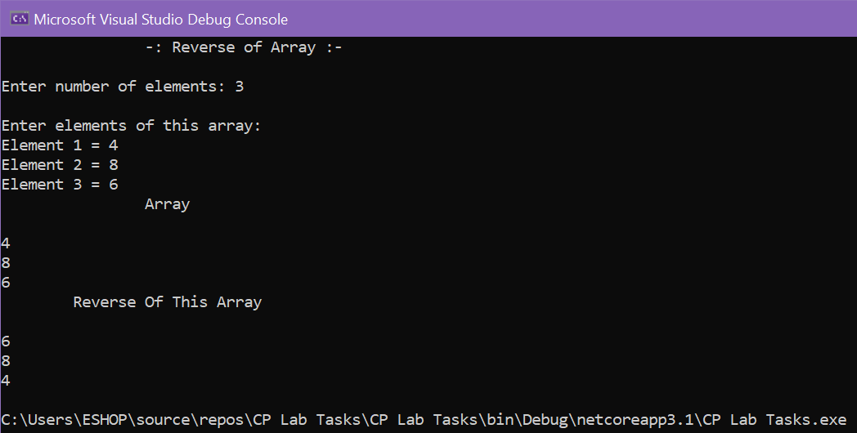

Task No 05: Design a fully functional calculator using function.

Input:

using System;

using System.Collections.Generic;

using System.ComponentModel;

using System.Data;

using System.Drawing;

using System.Linq;

using System.Text;

using System.Threading.Tasks;

using System.Windows.Forms;

namespace Calculator

{

public partial class Form1 : Form

{

public Form1()

{

InitializeComponent();

}

static void add(int num1, int num2)

{

int add = num1 + num2;

MessageBox.Show("The sum is " + add);

}

static void Sub(int num1, int num2)

{

int Sub = num1 - num2;

MessageBox.Show("The Difference is " + Sub);

}

static void Mul(int num1, int num2)

{

int Mul = num1 * num2;

MessageBox.Show("The Product is " + Mul);

}

static void Div(int num1, int num2)

{

int Div = num1 / num2;

MessageBox.Show("The Answer is " + Div);

}

private void Form1_Load(object sender, EventArgs e)

{

}

private void lbl1_Click(object sender, EventArgs e)

{

}

private void btncalculate_Click(object sender, EventArgs e)

{

int num1 = Convert.ToInt32(txtnum1.Text);

int num2 = Convert.ToInt32(txtnum2.Text);

if (rbsum.Checked == true)

{

add(num1, num2);

}

else if (rbsub.Checked == true)

{

Sub(num1, num2);

}

else if (rbmultiply.Checked==true)

{

Mul(num1, num2);

}

else if (rbdivide.Checked==true)

{

Div(num1, num2);

}

else

{

MessageBox.Show("You have not Selected any option!");

}

}

}

}

Output:

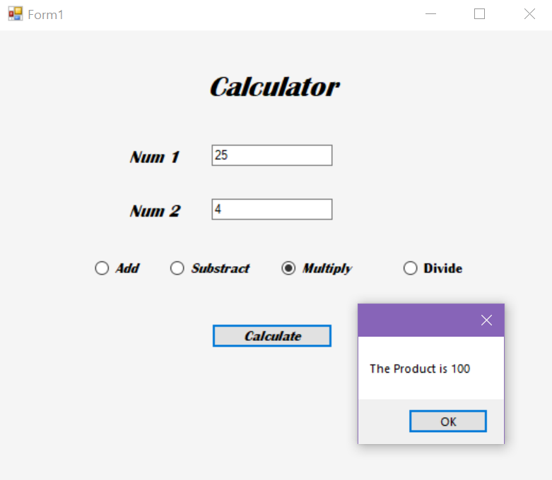

Task No 06: Design a WFP of your marks sheet. For (int i=5; i<10; i++) Result=2*i

Input:

Output: